Belgian Congo (The Congo was controlled by a small European country called Belgium, which was run by King Leopold.

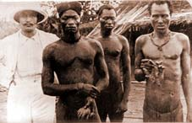

What is this picture showing and what can it teach us about Imperialism?

Cutting off hands (mutilation) was a common punishment in the Congo for not working fast enough or as a way to punish whole tribes for rebelling against the Belgian authorities.

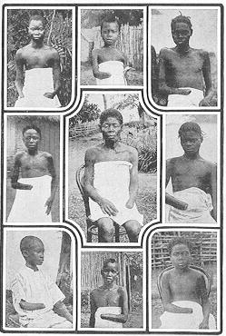

How would this impact the Congolese people psychologically?

